**Sequence Diagram**

Login/Logout

* Entity classes: User, ESN Directory
* Boundary classes: LoginLogoutInterface
* Controller class: AuthenticationController

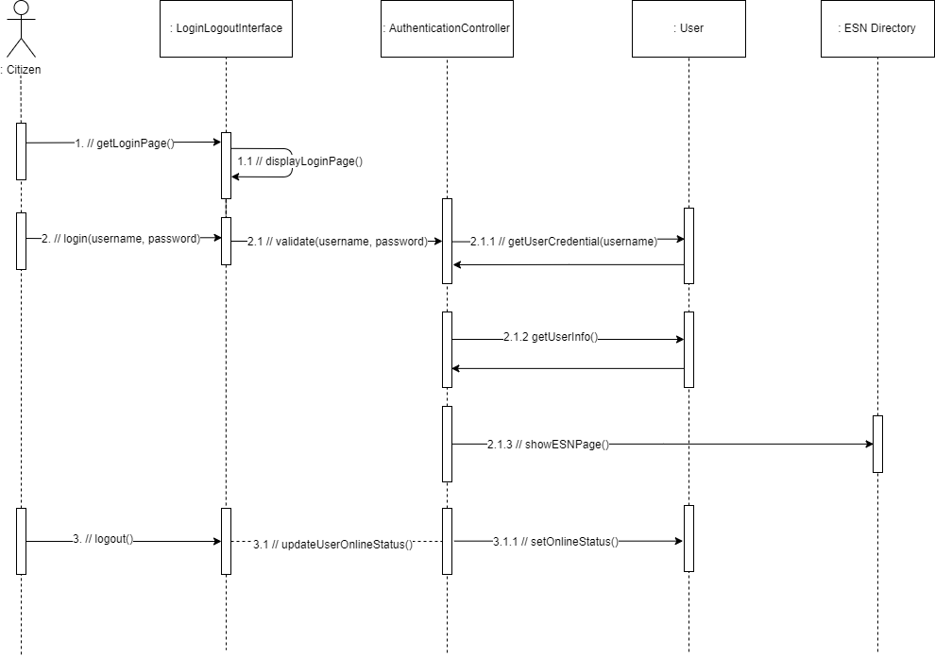

**Class Diagram**

Login/Logout

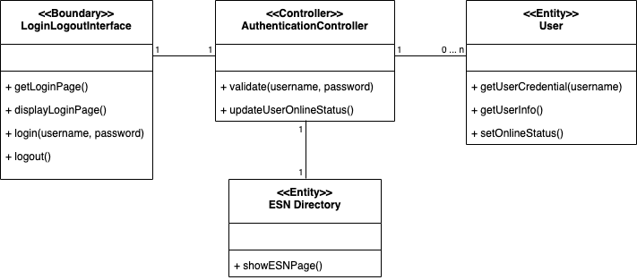

**Mapping between UML Diagram and Code Structure**

|  |  |  |
| --- | --- | --- |
| Analysis Class Type | Analysis Class | Corresponding Code Element |
| Boundary | LoginLogoutInterface | frontend/page/login.js |
| Control | AuthenticationController | backend/controllers/auth.js |
| Entity | User | backend/models/User.ts |
| ESN Directory | backend/models/User.ts |